Metformin prescribing in chronic kidney disease
Metformin is indicated for the treatment of type 2 diabetes mellitus, particularly in overweight patients, when dietary management and exercise alone does not result in adequate glycaemic control.

Metformin Tablets may be used as monotherapy or in combination with other oral antidiabetic agents or with insulin. As metformin is excreted by the kidneys, renal function should be regularly assessed.

Before starting treatment with metformin, check renal function.
Do not start metformin treatment if eGFR is less than 30 mL/min/1.73 m².
During treatment with metformin monitor renal function:
At least once a year in people with normal renal function.
At least twice a year in people with additional risk factors for renal impairment, such as the elderly, or if deterioration in renal function is suspected.
Review the dose of metformin if eGFR is less than 60 mL/min/1.73 m².
Stop treatment with metformin:
If eGFR is less than 30 mL/min/1.73 m².
In people at risk of tissue hypoxia or sudden deterioration in renal function.

Dose adjustments required for patients with renal impairment
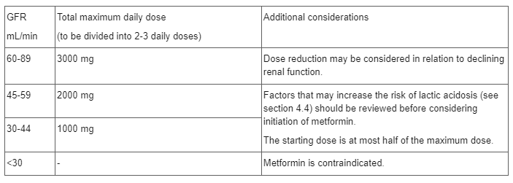
Renal monitoring advice is based on the total daily dose of Metformin regardless of combination or form e.g., Immediate release or Modified Release
Please consult the emc product literature for the specific Metformin product that is being prescribed, for extra information.
NICE NG28 has produced a 5-page summary on factors to consider when choosing, reviewing and changing medicines in adults with type 2 diabetes.
LSCMMG also has a useful Guideline for antihyperglycaemic therapy in adults

